Week 1 – Introduce yourself!

This is an Individual Lab!

|  |  |
| --- | --- |
| Name: | David Rivera |
| Student Number: | 137648226 |
| Where are you from: | Colombian/Spanish |
| What languages do you speak: | Spanish  English  French (Very basic BUT I do understand swear words Including: merde, putain They’re very similar in spanish) |
| Work experience: | Customer Service Representative (Loblaws) |
| Where did you go to school before this: | I took two gap years after high school. |
| What program are you in? (CPP, CPA, CPAC) | CPA Although I really want to transfer to a proper CS Degree |
| How are you doing at school? | I’m a bit of a mixed bag. I wouldn’t consider myself as an Excellent Student but I’m not necessarily bad either. My grades do not reflect my abilities mostly because school shuts my creative expression |
| List students in the class that you would like to work with: | Anyone you notice that HAS A PASSION AND DESIRE TO DO THINGS that’s the people and students you gotta be surrounded by in life. |
| List the students in the class that you don’t want to work with (it happens!): | Anyone you see that has basic responses in this doc |
| Lab attendance is mandatory for tests and strongly encouraged for the rest of the lab periods. Some students prefer to interact online, so if you would prefer to meet with your group online, then please indicate online here. | * I’d prefer to meet in person. I feel like that’s the best way to interact with group members. |
| During the day, when are you most productive with school work? | As much as I hate it, I get the most done in the night. I dont know what it is |
| What do you like to do outside of school?: | I LOVE CODING, It is my passion it is what I do most of the time and it is what I wanna do for the rest of it. |
| Academic Integrity issues will not be tolerated in this course. Complete Seneca’s Academic Integrity module and share the link to your badge  https://cfdev.senecacollege.ca/tl/forstudents/integrityinaction/ | https://factory.cancred.ca/v1/assertion/bb369fcb9987a98926bf41e8fe52f63ab35fb603 |
| Have you started looking for job opportunities? If so, where? | In the moment I'm writing this I’m still working on the details regarding my resume. But I will start applying next week. |
| What previous jobs have you held? | Loblaws, Customer Service Representative |
| Are you more interested in: Freelance work? Programmer? Analyst? Project Manager? something else...? | Programming all the way in |
| What is your favourite programming language? | I’ve explored many programming languages.(C++/C, JS/TS, Rust, Golang, Python) And I’ve got to understand that ultimately the language one person chooses is not important. What is important is the problem solving and research skills used when approaching a challenge.  But if there’s one set of features, I enjoy of one of them It’d be STD Library from C++. It really simplifies and saves a lot of boiler plate code used on any kind of project. If only Its compiler gave better errors, its linking process wasn’t as terrible and outdated as it is, its Approach on Inheritance wasn’t as brainfucked and if it was memory safe. We’d talking about the perfect programming language.  (Now that I think of, Rust solves a lot of these. I really gotta dive deeper into it As I haven’t really explored it further. |
| What web based platforms (.net, J2EE, JavaScript) have you worked with? | I’ve used your run of the mill kind of platforms( - NextJS   * React * NodeJS * NextJS * Google Cloud * Docker, I’ve used it to deploy web application. |
| Aside from Visual Paradigm, what non-programming development tools have you used?  Do you have a favourite? | I’ve gotta recognize VP It’s an important peace of software in the world of IT but Im not a huge fan of it. Perhaps because of its dinosaur-esque design. I haven’t used any other tools related to problem abstraction |

Using Visual Paradigm, please create a class diagram and a sequence diagram for the following scenario. Copy and paste your diagrams into this document and submit this document and your .vpp file as part of your submission.

Please refer to the ProTKD Case study for the background information to this scenario.

|  |  |  |  |
| --- | --- | --- | --- |
| Use Case Name | Add a class to a schedule | | |
| Triggering Event | Demand for a class | | |
| Brief Description | Allows the Registration Staff to add a class to the weekly schedule. | | |
| Actors | Registration Staff | | |
| Related Use Cases |  | | |
| Preconditions | Registration Staff has opened the class and schedule menu | | |
| Post Conditions | Class is scheduled and ready for Registration | | |
| Flow of activities | Actor | | System |
|  | 1. | Selects the Semester Schedule option | Displays a list of Semester/locations, prompts for selection |
|  | 2. | Selects semester and location | Displays a weekly calendar for the semester/location, displaying classes currently scheduled. Displays a list of classes. |
|  | 3. | Selects class, day of week and start time to add to schedule | Displays a weekly calendar for the semester/location, displaying classes currently scheduled. Displays a list of classes. |
|  | 4. | Repeat above step until all classes have been added to the schedule  Requests to save | Scheduled items are save. |
| Exception Conditions | * Registration Staff choose to cancel scheduling classes | | |

Diagrams

Class Diagram:

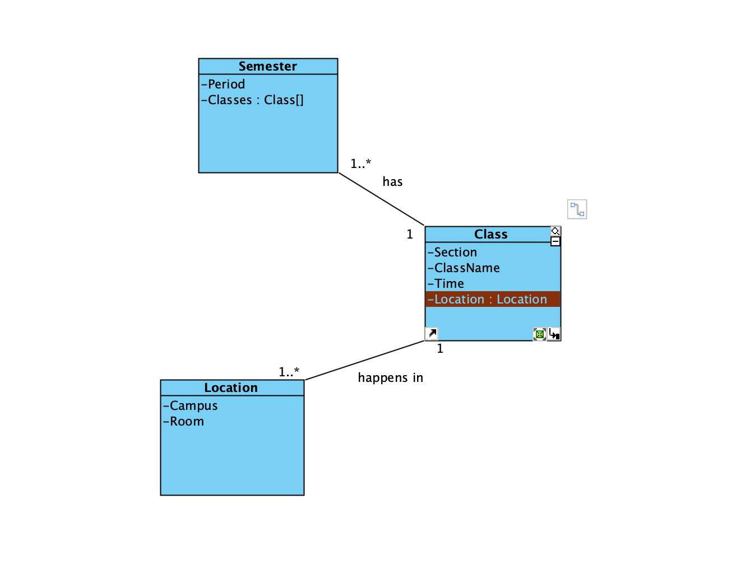

Sequence Diagram:

Steps 1-2

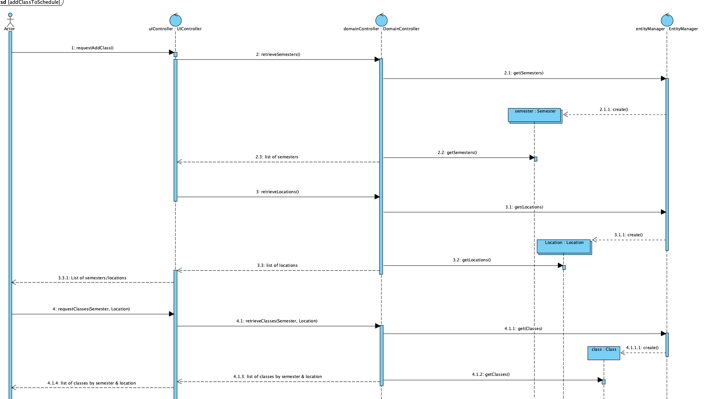

Steps 3-4

